Iter1.2 Empathy
G3T3
Introduction
Empathy Notes
1. Participant 1 – Year 1 SMU Business Student
2. Participant 2 – Year 3 SMU Exchange Student from Barcelona (1 semester)
3. Participant 3 – Year 2 SMU Exchange Student from Greece (1 semester)
4. Participant 4 – Year 3 NUS Architecture Student
5. Participant 5 – Mother of 2 University Boys
6. Participant 6 – Year 2 SMU SCIS Student
7. Participant 7 – Mother of 2 University Girls
8. Participant 8 – Mother of 1 University Boy and 1 Polytechnic Boy
9. Participant 9 – Year 4 NTU Business Student
10. Participant 10 – Year 1 SMU Business Student
Summary
Interview Statistics
Compilation of each Empathy Cluster/Critical Incidents
Insights Summary
Breakdowns and Ideas
1. Breakdown 1: The Communication Breakdown
Description
Ideas/Inspirations
2. Breakdown 2: The Location Breakdown
Description
Ideas/Inspirations
3. Breakdown 3: The Vouch Breakdown
Description
Ideas/Inspirations

Introduction
- How did you find people to empathize with?
We reached out to coursemates and friends within our own social circles who regularly go out at night, primarily SMU students (local and exchange students) and where possible, their parents or friends as well.

- What activity(ies) did you empathize with?
Instead of just observing nights out, we interviewed students and parents about what actually happens from pre-drinks to getting home late.
Students walked us through spontaneous venue changes and dying phone batteries, while parents shared with us their anxiety of unanswered calls and strict curfews.
These experiences have given us insights into the gaps SafeSip can fill by giving students their freedom while giving parents a peace of mind.

Empathy Notes

Participant 1 – Year 1 SMU Business Student
Google meet call: 03/09/2026, 3:00PM - 3:30PM
Interview:
- Q: How does a typical Friday night look like for you, from the moment you decide to go out?
"Honestly it's pretty last minute most of the time. Like someone in my group chat will just say 'is anyone going to zouk today’ at like 7pm and suddenly we're all getting ready. I don't really plan ahead, I just tell my parents 'hey I'm going out' and that's it."
- Q: What happens when something changes mid-plan? eg. You switch venues or the group splits up
“Oh it happens quite a lot actually. We’ll start at one place, do a vibe-check of our surroundings, and then move somewhere else if we aren’t feeling it. Nobody informs anyone outside the group. My parents have no idea, so they’ll still think I'm at the first location. That is if they even know I'm out at all.”
- Q: Tell me about a time you felt like you had to choose between having fun and keeping your parents calm.
“There was once when we were having a really good time, but my phone kept buzzing. I knew it was my mom. I stepped outside the club just to reply so she would stop calling, and by the time I went back in, the mood was kind of dead for me. All I could think about was the interaction with my parents instead of enjoying myself.”
- Q: Has a friend ever had to ‘vouch’ for you to your parents, or vice versa?
“Yes, my friend has picked up my phone before and told my mom that I was fine and that she was looking out for me when I was too tipsy to text properly. It worked, and my mum trusted her too. So I guess… having someone else confirm you’re okay, especially when it’s someone they know, actually calms parents down faster than the person themselves texting.

Comments:
- Plans are spontaneous and undocumented, just informal group-chat coordination
- Relaxed when talking about nights out, but became hesitant when discussing about interactions with parents
Photo: 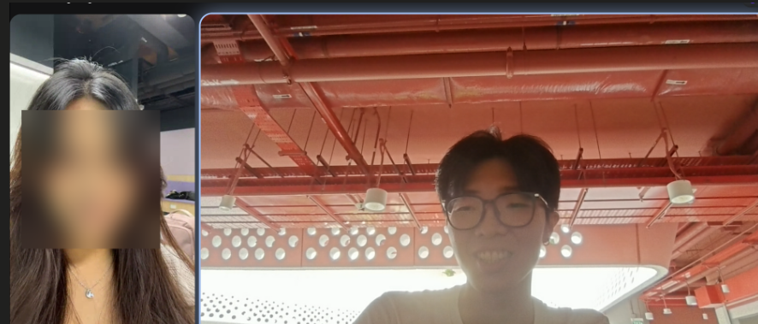

Participant 2 – Year 3 SMU Exchange Student from Barcelona (1 semester)
In-Person Meetup: 03/09/2026, 4:00PM - 4:30PM
Interview:
- Q: How does a typical Friday night look like for you, from the moment you decide to go out?
"Back home in Barcelona we don't even leave the house before midnight, so here it's funny because everyone wants to go out at like 9pm. My exchange friends and I usually decide in the afternoon, maybe over lunch, and then it's just a Telegram group chat that fills up with plans. My parents are in Spain, so there's a six-hour time difference. By the time I'm actually heading out, it's lunch time for them, so they are active and waiting for me to inform them of my plans every time."
- Q: What happens when something changes mid-plan? eg. You switch venues or the group splits up.
"All the time. Someone always wants to go to a rooftop bar instead, or we hear about an event somewhere else. Because my parents are not in the same country, they don't really expect updates on location — they just want to know I'm 'out with friends' generally. It's actually my roommate here who worries more if the group splits, because we always return home together and if something would happen she's the one who would have to explain to my parents."
- Q: Tell me about a time you felt like you had to choose between having fun and keeping your parents calm.
"Honestly not really; my parents trust me a lot because I'm already 22 and this isn't my first time living abroad. But I did feel that pressure with my host family here, sort of. I stayed at a homestay for the first month and the 'auntie' would wait up for me. I felt guilty coming back late even though nothing was wrong, so I started messaging her an ETA, which I never had to do at home."
- Q: Has a friend ever had to 'vouch' for you to your parents, or vice versa?
"Not to my own parents, but I've done it for other exchange students, texting their family in a language they understand, or just replying 'she's with me, we're fine' when someone's phone died. It's a small international-student thing, we kind of look out for each other's parents too."
Comments:
- Experienced communication issues not with her overseas parents, but with a local homestay "auntie" who stayed up for her, forcing her to manually message ETAs to alleviate her auntie’s anxiety.
- Relies on roommates to take on the burden of accountability if the group splits, with friends actively vouching for each other by texting overseas families in their native languages when phones run out of battery.
- Due to established trust and a six-hour time difference, her parents only expect a basic "out with friends" status update rather than real-time location updates.
Photo:


Participant 3 – Year 2 SMU Exchange Student from Greece (1 semester)
Video Call: 03/09/2026, 5:00PM - 5:40PM
Interview:
- Q: How does a typical Friday night look like for you, from the moment you decide to go out?
"For me, plans are made mostly through group chats. There are sixty people in one chat, so plans can change every five minutes. I don't message my parents before going out at all, actually. Back in Greece it's normal to just go, and nights don't really start until pretty late anyway, so if my parents ask 'what are you doing this weekend' I'd just say 'going out' and that's the whole conversation. But to be completely honest they do have my location and they are not aware of Wednesday ladies night."
- Q: What happens when something changes mid-plan? eg. You switch venues or the group splits up.
"It's chaotic. We'll say we're meeting at Clarke Quay and then half the group is like 'actually let's go to a house party at someone's condo' and the location just changes on WhatsApp. If my parents ever asked where exactly I was at 2am, I genuinely wouldn't be able to tell them the address, I'd have to ask my friends.
- Q: Tell me about a time you felt like you had to choose between having fun and keeping your parents calm.
"There was one night my phone died around 1am and I only realized the next morning I had three missed calls from my mom. With the five-hour gap, 1am here is around 8pm in Greece, so she was wide awake and saw news on social media about a stabbing at a nightclub in Johor Bahru . My family travels a lot, and we'd actually been to JB together on a trip before, so the place wasn't some random name to her, she could picture exactly where it was. That's what made her panic, not being able to reach me right when it felt close to home. If it had been the middle of the night for her she might not have noticed until morning, but because our nights overlap with her evening, she catches things almost in real time. I felt bad, but also — I didn’t know that she was worried and, what was I supposed to do, leave the party to charge my phone just in case? I ended up just calling her back at home when I learned what she went through”
- Q: Has a friend ever had to 'vouch' for you to your parents, or vice versa?
"Yeah, after that phone-dying incident, my roommate added my mom on WhatsApp, just so there's a backup contact who's actually in Singapore with me. My mom didn't ask her anything that night, but it's become this unspoken safety net now. I think it made my mom feel like there's a real person here she can reach if I ever go dark again."
Comments:
- Low proactive communication baseline with parents; check-ins are reactive, triggered by a scare rather than routine.
- A single missed-communication incident (dead phone + news trigger) permanently changed the "system", a human backup contact was added after the fact.
- Location fluidity within a night is treated as normal/unremarkable by the student, but is exactly what breaks a parent's peace of mind.
Photo:


Participant 4 – Year 3 NUS Architecture Student
Google meet call : 05/09/2026, 9.30PM - 10:00PM
Interview:
- Q : How does a typical Friday night look like for you, from the moment you decide to go out?
“My Friday night is normally pretty chill, but I would say most of the time it's very unplanned. We all are tired/stressed after the week filled with lectures so we usually find some time on Friday nights to chill out. I head out from my Hall around 9pm to meet my friends. I have a somewhat fixed friend circle so I pretty much always go out with them. By 10.30pm, we're doing tower after tower of beer or sharing bottles of alcohol. It's very easy for me to lose track of how much alcohol I've had. I try to pace myself, but when the group orders shots, it’s hard to say no due to peer pressure. We usually leave the bar around 2-3am and whoever is sober enough will coordinate a Grab or Gojek back.”

- Q : Do you inform your parents of your whereabouts / activities?
“Since we stay in NUS Hall, many people think that we have a lot of freedom to do whatever and go wherever we want. However, my parents are quite controlling. They have set up location sharing features on my phone so I cannot lie to them as to where I will be going. My parents constantly worry for my safety and keep texting and ringing me to check if I am safe or have reached back.”

- Q : What happens when something changes mid-plan? eg. You switch venues or the group splits up.
“We try to stay together as a group as much as possible. But there have been instances where we just didn’t like the place and wanted to go somewhere else, like grab supper at Lau Pa Sat after drinking. Sometimes I forget to tell my parents that we are going somewhere else, and yes, when my location changes they will start texting me to ask if I am ok.”

- Q : Do you find it annoying that your parents keep worrying for your safety?
“Yes, it is very annoying. Sometimes it gets so bad that it spoils my mood and I feel like going back. But I do understand their concerns regarding my safety as well. I feel that the ‘location tracking’ system that current apps have now is not sufficient to ensure safety.”
- Q : Tell me about a time you felt like you had to choose between having fun and keeping your parents calm.
“There was this one time I forgot to charge my phone and no one brought powerbanks. I told my parents about the low battery situation and that I will text them right after I went back to hall. I also told them that I will be safe, and specifically not to call any of my friends and bother them. We were out longer than expected and my friend’s phone started ringing. Turns out it was my parents asking him where I was. It was very embarrassing for me and spoiled my mood.”
- Q : Has a friend ever had to ‘vouch’ for you to your parents, or vice versa?
“There have been so many times my friends had to vouch for me to my parents because I did not reply to their texts as I was a little too drunk.”
Comments:
- Student finds his controlling parents very annoying - no sense of freedom and always being questioned
- However, he understands his parents ‘concern for safety’ and thinks that these apps should have better functions beyond relaying just location
Photo:
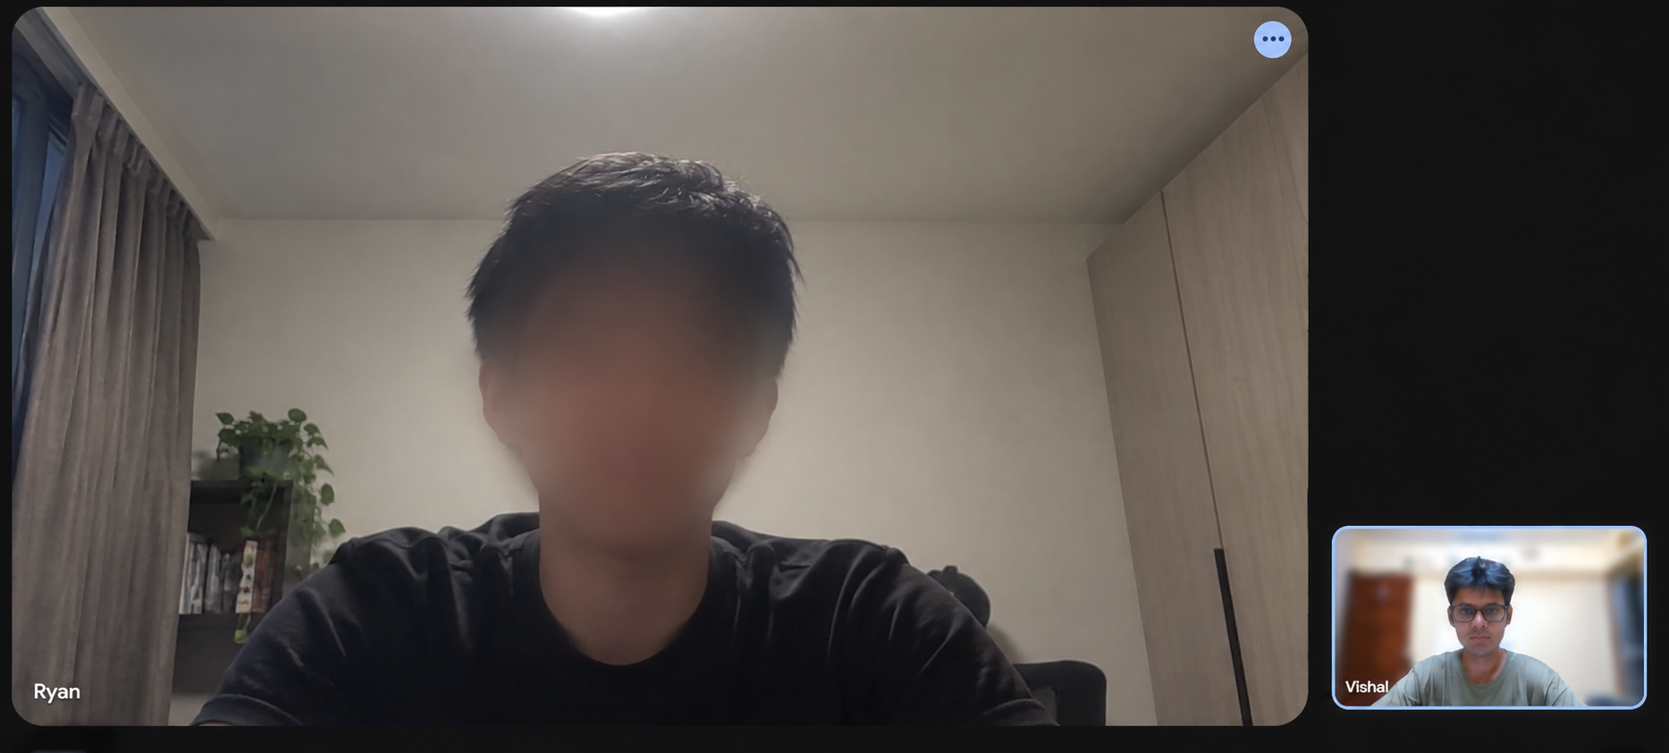

Participant 5 – Mother of 2 University Boys
In-Person Meeting: 05/09/2026, 10:00PM - 10:20PM
Interview:
- Q: Tell me about the last time your child went out late. Walk me through your thoughts and actions from the moment they left the house until they returned.
“There was a time my child went out for [a] movie and came home late. As my child is quite independent, he did inform me beforehand that he would be going for [a] movie. However, he didn’t come back home at the time he told me he would after the movie, so I was a bit worried. Usually, he comes back home around the time which he tells me, but that time he was almost 2 hours late. I did WhatsApp him to ask about what happened, but he only replied after some time that he stayed out with his friends longer than expected but was coming back.”
- Q: Recall a time where you couldn't reach your child while they were out. What did you think or feel, and what were the immediate next steps you took?
“I remember there was once I could not call my son when he was playing badminton outside and did not have his phone on him. I felt worried and I left a message letting him know to call me back when he reads my message.”
- Q: How do you usually agree on updates with your child before they leave, and how does that actually play out in reality?
“I usually let my kids have their own time as they are already in university, but if they are going out with friends and coming home late, they have to let me know as I need to know whether to prepare dinner for them. Usually, they always come back around the time they inform me.”
- Q: Think about a time you felt completely at ease while your child was out late at night. What specific information, action, or context gave you that relief?
“A message from them that they are ok usually gives me relief when my kids are out late at night.”
Comments:
- Respects her kids’ independence as they are university-aged, but still requires a baseline expectation (e.g. what time will they be back home).
- Anxiety triggered by timeline deviations such as unexpected and noticeable deviations of time agreed by kids to return home.
- While she does not require her kids to share their location all the time, she requires them to text back that they are fine or explain a delay, otherwise she gets worried.
Photo:


Participant 6 – Year 2 SMU SCIS Student
Google meet call: Start 05/09/2026: 11:30pm - End 05/09/2026: 11:59pm
Interview:
- Q: How does a typical Friday night look like for you, from the moment you decide to go out?
“I would say that it’s pretty structured since we usually predrink at a friend’s place around 6pm then we head down to the club around 8pm. After that it’s a blur until like 4 or 5am when the club literally kicks us all out because they’re closing. Next thing I would remember is waking up at home, with no idea how I got there half the time.”
- Q: What happens when something changes mid-plan? eg. You switch venues or the group splits up
“I don’t think anybody really communicates it properly. For example, we’ll predrink together but by midnight half the group is gone to a different club, or someone just left and went home without saying bye. It’s really chaotic and sometimes I’ve genuinely just found myself alone outside a place with no idea where my friends went.”
- Q: Tell me about a time you felt like you had to choose between having fun and keeping your parents calm.
“Honestly my parents don’t really check up on me like that anymore. But it’s more my friends now like someone will just send an update text in the group chat then everyone starts sending a selfie to show they’re still standing. If you don’t reply people actually start worrying, so even if I’m half dead I’ll still force myself to take a photo just so nobody comes looking for me.”
Q: Has a friend ever had to ‘vouch’ for you to your parents, or vice versa?
“Not parents, but friends vouching for friends for sure. I’ve woken up on the side of the road drunk a few times, and it’s always been a friend who’s texted the group like ‘he’s fine, he’s just sleeping it off” so nobody will panic. Happens to the best of us, and it’s kind of normalized in our friend group at this point”

Comments:
- Parental concern is largely absent; ‘Reassurance loop’ has shifted entirely to friends
- Selfie ritual is an existing informal solution that the participant and his friend group uses
- Memory blackout between clubbing and waking up at home is a recurring safety gap
Photo: 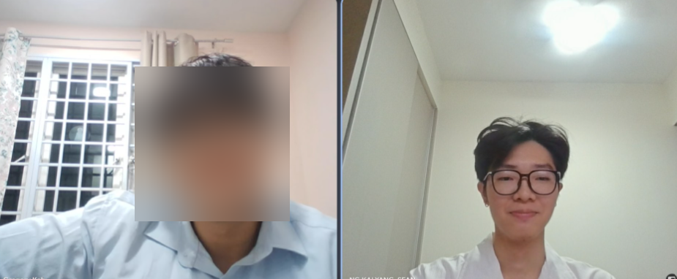

Participant 7 – Mother of 2 University Girls
In-Person Meeting: 06/09/2026, 12:00pm - 12:23pm
Interview
- Q: Tell me about the last time your child went out late. Walk me through your thoughts and actions from the moment they left the house until they returned.
“My second daughter went out to Johor Bahru two Sundays ago. Sundays are usually reserved for family time. I was annoyed but I trusted she was old enough to know what she was doing. She goes out so often now so I’m more used to it. Honestly, after [a] long day at work, I don’t have enough energy to constantly worry about her as I have another younger son to take care of. I just trust her to update me.”
Q: Recall a time where you couldn't reach your child while they were out. What did you think or feel, and what were the immediate next steps you took?
“There was a time where my daughter was out late without telling me after I clearly told her about her curfew (1030pm). She was still in junior college at that time and was already not doing well in school. I didn’t like that she kept going out as even though she updated, it wasn’t clear to me who she was hanging out with. I was more worried about her studies than she was. That night, I kept calling her but she didn’t want to pick up. There were about 15 missed calls. I got even more worried because I didn’t know whether she was safe. Only when I texted her and showed her I was angry, then she called me back.”
- Q: How do you usually agree on updates with your child before they leave, and how does that actually play out in reality?
“It depends on which child. Usually my oldest daughter will just let me know the night before that she is going out but usually she comes home before her curfew (12am). For my second daughter, she usually goes out late at night until the next morning so she always updates me on what time she leaves the house, and sends me pictures of her and her friends that makes me feel more at ease. She is responsible and updates me via texts, calls and photos whenever. The next day when I see her, she will also give me in person updates and that makes me feel reassured.”
- Q: Think about a time you felt completely at ease while your child was out late at night. What specific information, action, or context gave you that relief?
“When she goes out with people I was familiar with and when she updates me through texts and photos.”
Comments:
- She trusts them and knows that they are responsible enough to update.
- Also has baseline expectations (updates)
Photo:


Participant 8 – Mother of 1 University Boy and 1 Polytechnic Boy
In-Person Meeting: 06/09/2026, 5:30PM - 5:40PM
Interview:
- Q: Tell me about the last time your child went out late. Walk me through your thoughts and actions from the moment they left the house until they returned.
“Actually, just yesterday, my son went out from noon till about 12am. However, I didn’t feel panicked or lost as I had an app to track him (“Find My” built-in apple app). As such, I could see where he was, and he also told me that he was working.”
Q: Recall a time where you couldn't reach your child while they were out. What did you think or feel, and what were the immediate next steps you took?
“Ok yeah, there was a time I can’t remember when, that he intentionally turned off his location, and also took a while to reply to my messages I sent him. When he did reply, he just said that he was on his way back. At that moment, I felt anxious as I couldn’t reach him, and also slightly angry as he turned off his location.”
- Q: How do you usually agree on updates with your child before they leave, and how does that actually play out in reality?
“Usually, I expect them to let me know where they are going, so I can expect what time they will return, so it’s important to have an update before they leave the house.”
- Q: Think about a time you felt completely at ease while your child was out late at night. What specific information, action, or context gave you that relief?
“Actually, this can link back to the first question. As he already told me beforehand that he is working and some more I could actually see his actual location, so that gave me peace of mind.”
Comments:
- She relies on a combination of location-tracking technology (Find My) and communication before leaving the house to keep herself updated on her kids’ whereabouts
- However, she became anxious and upset when her kids intentionally disabled their location sharing, further exacerbated by their unresponsiveness
- Requires context in the form of her kids’ destination and activity, before she mentally calculates their expected return time
Photo:


Participant 9 – Year 4 NTU Business Student
In-Person Meeting: 06/09/2026, 8:00PM - 8:30PM
Observation, Interview, or Immersion:
- Q: How does a typical Friday night look like for you, from the moment you decide to go out?
“After finishing lessons, me and my friends often go to Clarke Quay and grab some finger food and drinks. We enjoy staying out till late and often get lost in the conversation. I normally prefer to put my DND on my Iphone so I can just stay in the moment and I only return home at around 4am after talking and drinking with my friends or bar hopping.
- Q: What happens when something changes mid-plan? eg. You switch venues or the group splits up
“When the plans change, I just follow my friend around. Some of my friends don’t drink much or handle their alcohol better, so when we have to switch venues when bar-hopping or we split and go to 7-11 to grab some snacks, I stick with them since I feel more safe in their presence.
- Q: Tell me about a time you felt like you had to choose between having fun and keeping your parents calm.
“As mentioned earlier, I prefer to leave my phone on DND to stay in the moment. Sometimes when my parents call, they do not get through or I do not see the notifications of their calls. One time this happened to me when I was with my friends, my mother had called me 12 times by 1am. She had even texted me “you are in big trouble”. I immediately rushed home and my nightout was ruined.
- Q: Has a friend ever had to ‘vouch’ for you to your parents, or vice versa?
“My parents have met some of my friends before. When I am not sober and I see my parents call, I automatically hand my phone to my friends to reassure my parents that I am in safe hands. Though this works sometimes, my parents still do not trust my friends completely. Furthermore, if my friends answer the phone, they are aware that I am not sober and this angers them”
Comments:
- Prioritizes staying "in the moment" by using Do Not Disturb (DND), which inadvertently creates communication breakdowns, severe parental panic, and ruined outings.
- Relies heavily on her more sober friends for physical safety when changing venues, and uses them as communication proxies to "vouch" for her when she is drunk.
- However, proxy vouching actually backfires as when a friend answers her phone, it acts as proof that she is not sober, causing her parents anger instead of relief.
Photo:


Participant 10 – Year 1 SMU Business Student
In-Person Meeting: 07/09/2026, 8:00AM - 8:30AM
- Q: How does a typical Friday night look like for you, from the moment you decide to go out?
“I go out to Helen’s at night with my friends to drink. After that, we either return home or go to a club. At the club, we continue to drink or take shots and meet up with other friends. Sometimes we meet random people and they join our group. I often hang out with these people until late at night around 3am/4am.”
- Q: What happens when something changes mid-plan? eg. You switch venues or the group splits up
“When we split up or there are changes in plans, I just go with the flow. I follow whoever I see or whoever guides me out. Sometimes these are friends of friends or people I am unfamiliar with, but I often am not conscious or sober enough to see who is there or whether I know them”
- Q: Tell me about a time you felt like you had to choose between having fun and keeping your parents calm.
“One time when I was drunk, my friends were not around me and my parents called. They were quite upset that I had drank so much and was not in my senses. They called a Grab for me and made sure I shared my location with them. I did not even tell my friends before leaving since I was so scared. I immediately got into the Grab they called for me and got home.”
- Q: Has a friend ever had to ‘vouch’ for you to your parents, or vice versa?
“No, my parents do not have much trust in my friends. They prefer to know about my whereabouts personally rather than relying on third-party information. My parents think my friends are ‘bad influences’ and often tell me not to go out with them. I often have to ‘vouch’ for myself to my parents.”
Comments:
- Exhibits vulnerability when intoxicated, goes with the flow during venue changes, and often loses awareness of whether he is with trusted friends or random strangers.
- Faces strict parental intervention as his parents take immediate action (e.g. forcing location sharing and remotely booking a Grab for him) when they discover he is drunk and separated from friends.
- Peer safety nets are ineffective as his parents view his friends as "bad influences", forcing him to vouch for his own safety even when he is intoxicated and unable to do so.
Photo:


Summary

Interview Statistics
Total Participants | 10
Gender | 7 Female, 3 Male
Age Range | Students(7): 19-25  Parents(3): 40-50
Occupation | University Students, Housewife, Bank Client Relations Manager, Marketing Executive, etc.
Outing Frequency | Students: Weekly to multi-weekly late night outings (bars, clubs, hall drinkings)  Parents: Experience late-night monitoring on a weekly/ad-hoc basis

Compilation of each Empathy Cluster/Critical Incidents
- Spontaneous Plans and changing Venues: Students initiate outings impulsively through group chats, shifting venues along the way without documenting or communicating changes to parents.
- GPS Tracking without Context: While parents rely on location sharing for peace of mind, raw GPS coordinates on a map don’t explain why a student is moving or staying put. When students shift venues or location updates stall, the lack of status context triggers unnecessary parent panic.
- Uncontactability period: Loud venues, Do Not Disturb(DND) mods, and low phone batteries create a situation of communication blackout. Unanswered calls trigger severe parental panic, ruin student moods, or cause forced early departures.
- Informal Peer Safety Nets and vouching: Students naturally rely on friends to update and inform parents, or send “status selfies” when someone is too tipsy to reply. However, parents often distrust these friends, viewing them as bad influences.
- Reassurance Gap: Parents do not need to constantly be called but instead require basic contextual updates(e.g., Arrival, departure, return timing) to feel at ease.

Insights Summary
Category | Positive + | Negative -
Late-Night Outing Experience | - Freedom to unwind, socialize, and go with the flow after a busy week.  - Sense of security when moving with trusted friend groups. | - Students naturally check-up on their friends, suggesting that wellbeing safety systems should formalise existing social habits rather than introduce high effort ones.  - High alcohol consumption or unsureness of alcohol tolerance leads to blackouts, memory gaps, and inability to travel home safely.
Communication and Reassurance | - Proactive text or photo updates calms parents and builds long term trust.  - Spontaneous “selfie rituals” in group chats serve as quick, visual proof that the student is still safe and standing. | - The more parents seek reassurance through repeated contact, the more students disengage from communication to ensure a positive social experience.  - Missed calls due to DND mode or low phone battery triggers anxiety and impatience in parents.
Location Sharing and Parent Monitoring | - Pre-agreed curfews and simple check-ins give parents a peace of mind.  - Provides relief to parents to know the whereabouts of their child at specific venues. | - Parents seek reassurance rather than needing to know about location. Location only provides reassurance when paired with meaningful context.  - Disabling location tracking or sudden location changes raises parent suspicions.

Breakdowns and Ideas

Breakdown 1: The Communication Breakdown

Description
- Participant(s): 2, 3, 4, 9
- Goal(s):
  - Students want to enjoy a night out without constantly monitoring their phone and battery.
  - Parents want to be able to reach their child if necessary, especially late at night

Some students let their phone battery die, either because they do not carry a portable charger or simply do not think to charge while they are out, while others deliberately put phones on Do Not Disturb (DND) to stay present with friends. Participant 3’s phone died around 1am. At the same time, her mother saw news about a nightclub stabbing in Johor Bahru, a place their family had previously visited, which intensified her anxiety when she could not reach her daughter. Participant 9 similarly kept her phone on DND simply to “stay in the moment”, only to return to 12 missed calls and an angry text, cutting her night out short. Both cases highlighted that students wanted to be undistracted and present in the moment, while parents needed to be able to reach them and when they could not, parents got worried.

Ideas/Inspirations
- Automatic notification/text that sends a ‘low-battery’ alert to both parties (e.g 15%)
- Automated milestone notifications that passively update parents on child's status without requiring manual texts (e.g. sending automatic alerts when arriving at a venue or heading home)
- Implement a quick way to allow students to verify their well-being, while still easing parents’ anxiety (e.g. Timed well-being checks that escalate to parents if left unresponsive)

Breakdown 2: The Location Breakdown

Description
- Participant(s): 4, 7 8
- Goal(s):
  - Parents want to understand their child’s actual situation and well-being, not simply their physical location.
  - Students want location sharing to provide reassurance without having to explain every movement themselves.

Real time location tells parents where their child is, but not what is happening. A change in venue, an unexpected stop or stationary GPS pin can create uncertainty even when location sharing is working normally. Participant 4’s parents still call and text despite having his location, while Participants 7 and 8 show that parents feel more reassured when location is paired with contextual information such as activity, texts, photos and return times.

Ideas/Inspirations
- Summary of their movement is overlaid on the parent's map view so location is always paired with their child’s status, not just coordinates
- Low-friction Quick Status tags that students can tap to add context to their location without typing anything out (eg. “safe”, “im okay”)
- Crew-visible status messages so a location change comes with an explanation attached, rather than parents having to infer meaning from movement alone

Breakdown 3: The Vouch Breakdown

Description
- Participant(s): 1, 9, 10
- Goal(s):
  - Students want a trusted friend to reassure their parents when they can't do it themselves
  - Parents want reassurance from a source they can actually trust and not just whoever happens to answer the phone.

Students consistently turn to friends to vouch for them, but it only works if the parents already personally know that friend. Participant 1’s friend calmed her mum down, only because her mum trusted her friend. Participant 9 handed his phone to friends when she’s not sober, but her parents still don’t trust his friends completely, plus a friend answering meant that she was drunk, making her parents angrier instead of reassured. For participant 10, his parents view his friends as ‘bad influences’ outright and refuse third-party reassurances, forcing him to vouch for himself even when he’s in no state to do so. In all three cases, vouching is entirely ad hoc, with no pre-established trust, so it comes down to whether the parent happens to already know that person.

Ideas/Inspirations
- Include a registered Night Buddy system, where buddies are named and selected before the night out, so parents see a specific, pre-declared circle rather than an unknown voice on the phone
- "Contact Night Buddy" button on the parent's escalation screen, so parents can reach a trusted buddy directly instead of relying on the student's phone or whoever happens to pick it up.
- Status on the Crew tab, updated throughout the night, so a ‘safe’ status works as an ongoing vouch instead of something improvised only in the moment.

